Enrolling Kroger Plus Card in Community Rewards Program for LVTC.
- Go to website www.kroger.com. Click on “Register” to create account.
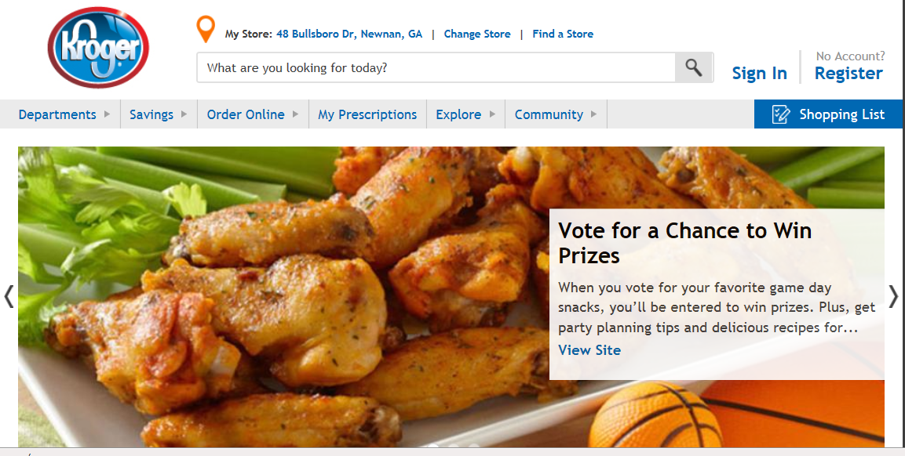
- Enter personal contact information.
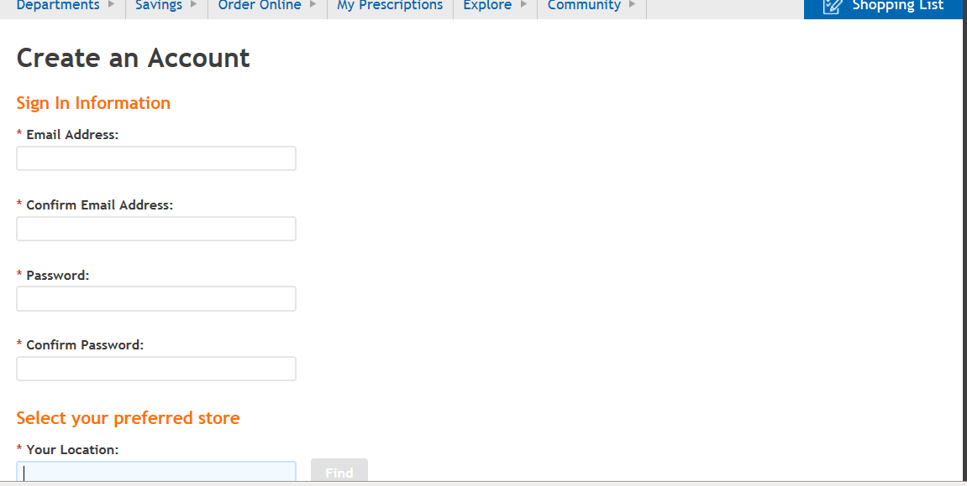

- Add Kroger Plus card to your account.
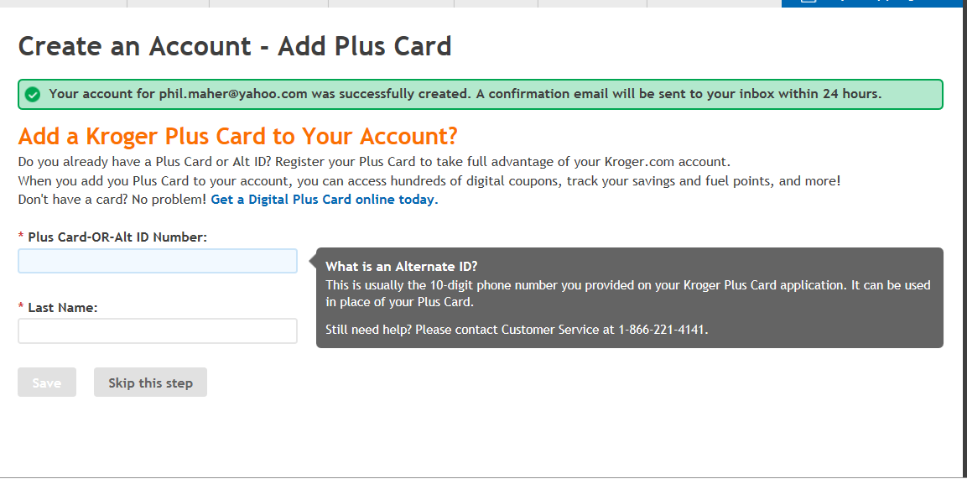

- On Account Summary page, scroll down to Community Rewards and click on “Edit”:
- Enter name/address
- Enter 72168 in search box.
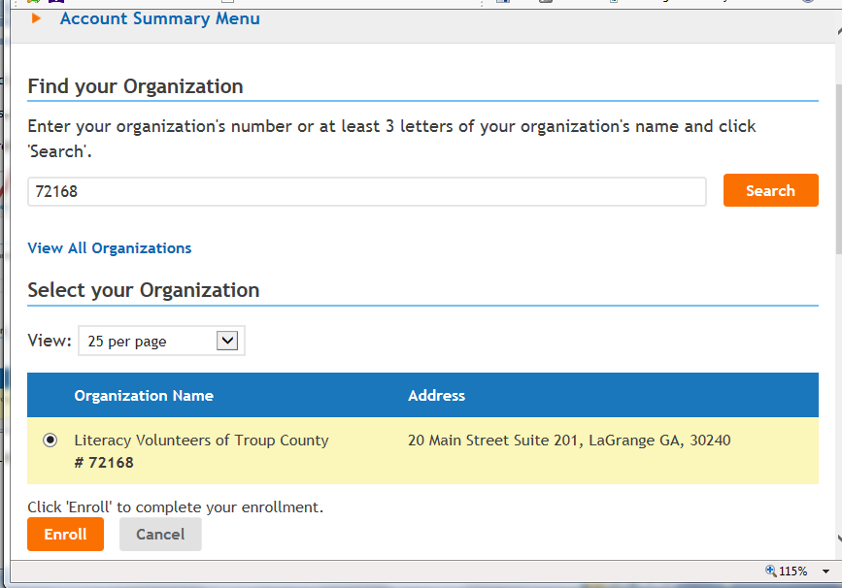
- Click circle next to Literacy Volunteers, then click “Enroll”
- Window below will appear when enrollment is complete.

klm 3/11/2015

